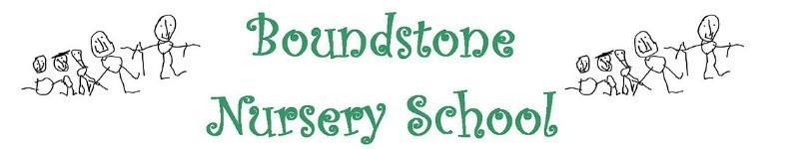

WEST SUSSEX NURSERY SCHOOLS FEDERATION

**Safer Sleep Policy**

Before the child starts Nursery, the Keyworker will ensure they discuss the safe sleep policy during the home visit or the taster sessions.

All staff are required to read the policy during their induction process.

Children, especially young babies, need to be placed to sleep on firm, flat surfaces. We will not use pushchairs, bouncers, or slings for sleep. Children should be placed to sleep on their back, with their feet at the foot of the cot, until they are able to move themselves from their back to their front. If a parent has been advised of a medical reason for their child to sleep on their front, then they must provide a Doctor’s note.

If dummies are supplied to help a child settle to sleep, we will take off any dummy chains to prevent choking. If a child’s dummy falls out of their mouth during sleep, we will not put it back in, unless they are awake/stirring.

Children must go to sleep in appropriate clothing, all hoodies and jumpers will be removed before bed. A layer of clothing can be removed if the sleep room is very warm. This also applies to their bedding. Blankets or sleeping bags must be the appropriate size and thickness for the child and the conditions of the room.

We will also take out any hair clips or ties to prevent a child putting these into their mouth while in the sleep room.

The sleep room aims to be between 16 and 20 degrees Celsius, this is monitored by a thermometer, and windows will be opened/heating adjusted accordingly. In the summer there will also be fans used to redirect the air.

In Chichester Nursery, there will be a member of staff in the Baby Room at all times whilst children are asleep in the sleep room. Staff are required to check on the children every 10 minutes and sign the sleep record at each interval.

In Bognor and Boundstone Nurseries, the sleeping area is on view to staff at all times. A member of staff will check on the children every 10 minutes and sign the sleep log.

The nursery will not allow a child to consume milk from a bottle in a cot or mat bed as a soother for settling to sleep, nor will we ‘dream feed’ a child their bottle while they are sleeping.

We will do our best to work in partnership with parents with regards to sleep limits and gently try to stir the children naturally by introducing some natural light and making a little noise - however we are not able to force a child to stay awake or fall asleep. We will not attempt to wake children before 45 minutes.

Staff members will provide resources such as The Lullaby Trust <https://www.lullabytrust.org.uk/> for any parents who require further information about the policy, or how to get their child to sleep as safely as possible.

**Date: Autumn 2024 To be Reviewed: Autumn 2027**